PID Controller Simulator

Hanshu Yu

1st September 2025

# Background

You have learned PID controller in the control course.

MATLAB is too expensive, I am broke and Python is free! So we program a simple PID controller simulator for our needs.

# Requirement

We make use of this standard unit feedback control loop model.

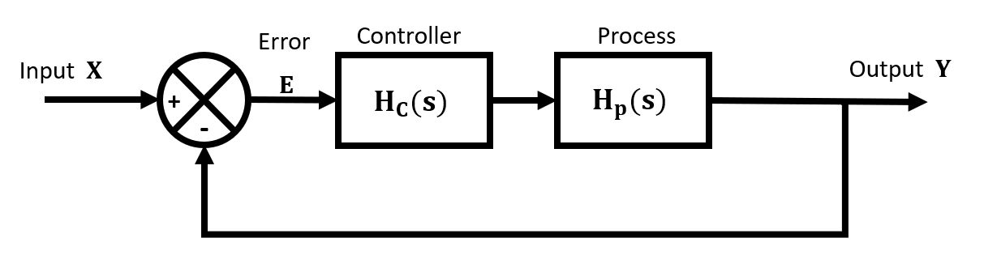

**To create:**

**A PID Controller simulator with graphical user interface.**

**Should have at least:**

1. Input: P
2. Input: I
3. Input: D
4. Input: System Transfer Function
5. Input: System Input (Let user select from Impulse response, Step response, Sinusoidal input response with user specified frequency)
6. Output: The corresponding time domain response together with time domain input in one plot.

(Exploratory bonus)

Can you create animated simulation instead of just a plot?

What happen if you add noise to the input signal? Can you either analyze or simulate?

What does that imply for PID controller tuning?

# Deliverables

1. A short report, clear and to the point.
   1. Min 1 page A4, max 7 pages A4 (excluding appendix)
   2. Suggested structure:
      * Introduction:
        + What is the task?
        + What needs to be analyzed?
      * Method:
        + How did you approach this problem?
        + Calculations you need by hand and/or simulations strategy.
        + How did you structure your code?
        + Select and describe a PID tuning method.
      * Results:
        + GUI design.
        + How to use your code?
        + Is it fully functional?
        + Screenshots of different simulation examples.
        + Demonstrate that you can realize a complete PID controller tuning process with the method you selected on an example process.
      * Reflection:
        + What did we do good?
        + What can be improved?
        + What did we learn while working on this code?
        + Discussion of PID controller tuning.
        + Is your system accurate?
2. Your code in appendix.

## 3.1 Report guideline

* Very concise and straight to the point. You do not need a cover page, you do not need contents like: “The purpose of this project……” You do not need 3rd person perspective language, just say “We decided……”,”We write ……”. You do not need background and too much description in detail.
* The report must be logical and easy to read, free from grammar & spelling mistakes.
* Screenshots must be clear and readable.
* I strongly suggest you to just copy and paste your code to the appendix, do not use screenshots, do not worry about the colors and general format that make your code look good, just make sure indentations are there when needed. Do make sure that the code readable, a direct copy from a dark theme IDE may make your code unreadable.
* Recommended format normal text: A4 paper, Arial, size 12, line space: multiple 1.25.
* Submit the report in groups, remember to include your names and student numbers on the report.

## 3.2 Code guideline

* It should work like what is described in the assignment.(Section 1 of this document)
* You should have necessary comments to the extent that you still can understand each line after leaving it for a week. You must be able to explain your code.